**Lesson Plan 6: Advanced Web Dev - Bootstrap Carousel and LightBox**

**Teacher Prep:**

* Go through the Document thoroughly and create the projects as guided.
* Look up the reference material links that have been provided.

**Project Showcase: (to be done at the start of the class at teacher end)**

* Open the provided project on VS Code before the class starts and check the live view on your browser.

**What is a Carousel?**

* Carousel is a slideshow for cycling through a series of contents.
* It is a flexible and responsive way of adding slides.

**Basic Steps of creating Carousel:**

1. Add the **.carousel** and **.slide** classes to the container along with an id.
2. Specify the slides in a <div> with class **.carousel-inner** and each slide defined with **.carousel-item** class.
3. Add the **.active** class to one of the slides to make the carousel visible; otherwise the carousel will not be visible.

**ADDING .carousel and .slide classes :**

Carousels require the use of an id (in this case id="myCarousel") for carousel controls to function properly.

The class="carousel" specifies that this <div> contains a carousel.

The .slide class adds a CSS transition and animation effect, which makes the items slide when showing a new item. Omit this class if you do not want this effect.

The data-ride="carousel" attribute tells Bootstrap to begin animating the carousel immediately when the page loads.

The indicators are the little lines at the bottom of each slide which indicates how many slides there are in the carousel, and which slide the user is currently viewing.

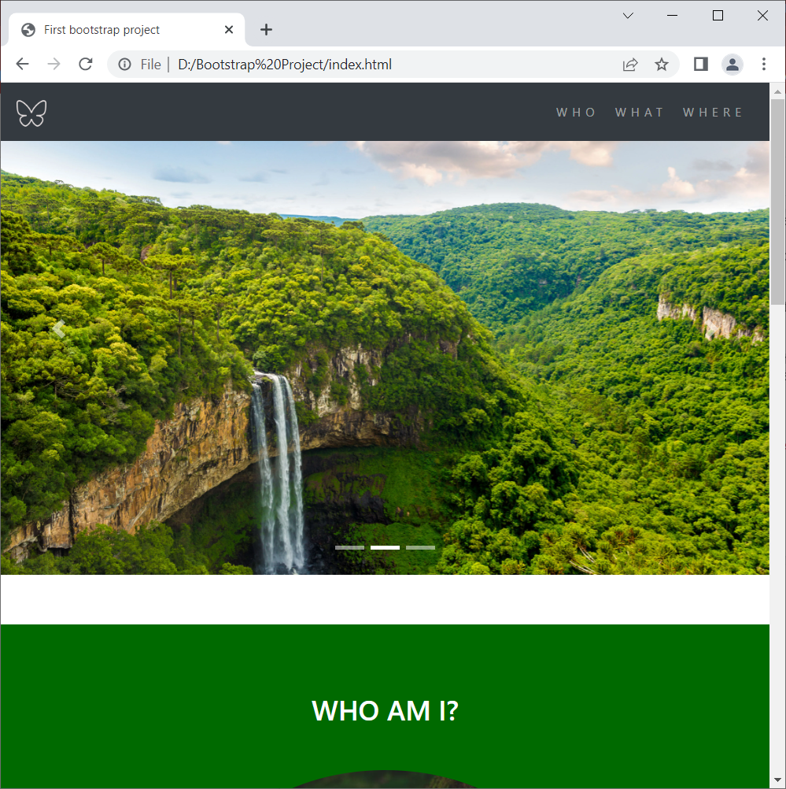

The indicators are specified in an ordered list with class .carousel-indicators.

The data-target attribute points to the id of the carousel.

The data-slide-to attribute specifies which slide to go to, when clicking on the specific line.

**Slides in a <div> with class .carousel-inner and each slide defined with .carousel-item class AND .active class**

The slides are specified in a <div> with class .carousel-inner.

The content of each slide is defined in a <div> with class .carousel-item. This can be text or images.

The .active class needs to be added to one of the slides. Otherwise, the carousel will not be visible.

**Left and Right Controls:**

This code adds "left" and "right" buttons that allows the user to go back and forth between the slides manually.

The data-slide attribute accepts the keywords "prev" or "next", which alters the slide position relative to its current position.



**LIGHTBOX OPTIONAL (ONLY FOR SMART KIDS)**

A lightbox is a combination of two components, a [**moda**l](https://en.wikipedia.org/wiki/Modal_window) and a **slide show**.

1. First div box with **class “row”** is a whole lightbox container which will have some pictures and we would be adding a lightbox effect to that.

This div box contains the attribute of **“data-toggle**” and **“data-target”**.

This makes it so clicking anything in the gallery opens the lightbox (i.e. modal).  
 data-target should be set to the id of the modal, which you will create later.

Next create a div box inside the main container which will have the carousel effect. Each of these div boxes will include the images that you wish to show in the carousel and lightbox.

These classes have a class named as "col-md-4 col-lg-3"

Defines how many equal portions of columns will there be in these different screen sizes.

The Bootstrap grid system has four classes:

**xs (for phones)**

**sm (for tablets)**

**md (for desktops)**

**lg (for larger desktops)**

The classes above can be combined to create more dynamic and flexible layouts.

**Tip:** Each class scales up, so if you wish to set the same widths for xs and sm, you only need to specify xs.

**col-lg-** stands for column large ≥ 1200px

**col-md-** stands for column medium ≥ 992px

**col-xs-** stands for column extra small ≥ 768px

Add **data-target="#carousel"** **data-slide-to="0"** to each image (or image wrapper).  
data-target should be set to the id of the carousel, which you will create later. And data-slide-to should be set according to where the image is in the gallery. The first image is 0, the second is 1, the third is 2, etc.

1. Create a new div box with class name **modal**

The **modal id** should match the **data-target** of the gallery element.

The **carousel id** should match the **data-target** of the images in the gallery.

The carousel slides should match the gallery images and must be in the same order.

Rest the code goes the same as for the carousel.

.